Order Of Service

Singing: Psalm 121—CW page 112

Reading: Psalm 95

Opening Hymn: TLH 1

Reading: Acts 18:1-11

Request Hymn: CW Supplement 702

Reading: Matthew 6:24

Sermon Hymn: TLH 23

Sermon Text: Mark 6:1-6

Rejected At Nazareth

Prayer

The Apostles’ Creed, TLH page 12

Holy Communion

The Lord's Prayer

The Blessing

Closing Hymn: TLH 45

* * * * * * * * * * *

Bible Study: Lambs: Bat
Sheep: Proverbs 17:16-20
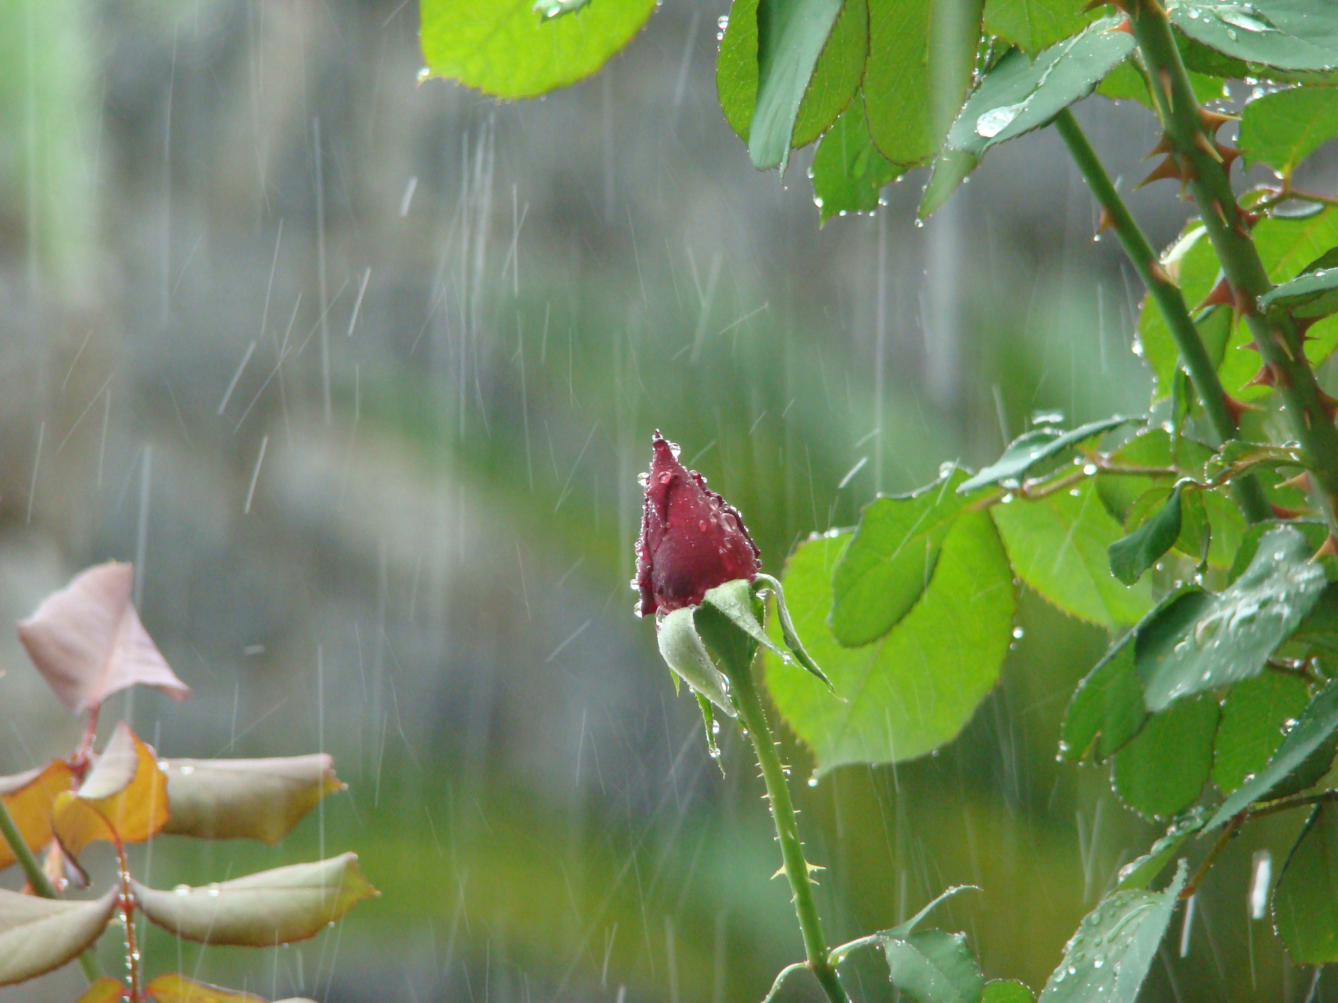

The Early Rain

Water
Of
Life

28 April 2019

W A T E R O F L I F E

Independent Christian Church—Conservative Lutheran Doctrine

Worship Service: 9:30 a.m. Bible Study: 10:45 a.m.

Larry Cooper, Pastor E-Mail address:
111 N. Ridge Road lcooper@wateroflife.cc
Coon Valley, WI 54623 Web Site:
www.wateroflife.cc

* * * * * * * * * * * * * * * * * * * * * * * * * * *

Sermon Text: Mark 6:1-6

Rejected At Nazareth

* * * * * * * * * * * * * * * * * * * * * * * * * * *

Mark 6:1 And he went out from thence, and came into his own country; and his disciples follow him.
:2 And when the sabbath day was come, he began to teach in the synagogue: and many hearing him were astonished, saying, From whence hath this man these things? and what wisdom is this which is given unto him, that even such mighty works are wrought by his hands?
:3 Is not this the carpenter, the son of Mary, the brother of James, and Joses, and of Juda, and Simon? and are not his sisters here with us? And they were offended at him.
:4 But Jesus said unto them, A prophet is not without honour, but in his own country, and among his own kin, and in his own house.
:5 And he could there do no mighty work, save that he laid his hands upon a few sick folk, and healed them.
:6 And he marvelled because of their unbelief. And he went round about the villages, teaching.

**********
Related Reading—John 1:1-14

John 1:1 In the beginning was the Word, and the Word was with God, and the Word was God.
:2 The same was in the beginning with God.
:3 All things were made by him; and without him was not any thing made that was made.
:4 In him was life; and the life was the light of men.
:5 And the light shineth in darkness; and the darkness comprehended it not.
:6 There was a man sent from God, whose name was John.
:7 The same came for a witness, to bear witness of the Light, that all men through him might believe.
:8 He was not that Light, but was sent to bear witness of that Light.
:9 That was the true Light, which lighteth every man that cometh into the world.
:10 He was in the world, and the world was made by him, and the world knew him not.
:11 He came unto his own, and his own received him not.
:12 But as many as received him, to them gave he power to become the sons of God, even to them that believe on his name:
:13 Which were born, not of blood, nor of the will of the flesh, nor of the will of man, but of God.
:14 And the Word was made flesh, and dwelt among us, (and we beheld his glory, the glory as of the only begotten of the Father,) full of grace and truth.

